

American International University-Bangladesh (AIUB)  
**Department of Computer Science  
Faculty of Science &Technology (FST)  
Fall 19_20**

**Section: J  
Group No: 01**

**Super Shop Management System**

A software Engineering project submitted

By

Taki Tazwar Parthib (18-36345-1) (takitazwar)

Sabikunnahar Talukder Pyaasa (18-36368-1) (sabikunnaharpyaasa)

Nila Maitra Chaity (18-36353-1) (nila1313)

Sadia Islam (18-36880-1) (sadia131)

The project will be evaluated for the following Course Outcomes

|  |  |
| --- | --- |
| CO3: Choose appropriate software engineering model in a software development environment | Total Marks |
|  |
| Project Background Analysis (needs, goal, benefits, etc.) [5Marks] |  |
| Appropriate Process Model Selection [5Marks] |  |
| Argumentation for model selection with Evidence [5Marks] |  |
| Completeness, Spelling, Grammar and Organization of the Answer [5Marks] |  |
|  | |
| CO4: Explain the roles and their responsibilities in the software project management activities | Total Marks |
|  |
| Content Knowledge (e.g. System Requirements, System Design) [5Marks] |  |
| Project Role identification [5Marks] |  |
| Responsibility Description [5Marks] |  |
| Completeness, Spelling, grammar and Organization of the Answer [5Marks] |  |

Contents

1. PROBLEM DOMAIN 3

1.1 Background to the Problem 3

1.2 Solution to the Problem 3

1.3 Existing / Related Solutions 4

2. SOFTWARE DEVELOPMENT LIFE CYCLE 5

2.1 Process Model: 5

2.2 Project Roll Identification and Responsibilities 5

2.3 Responsibilities of the development team 6

3. PRODUCT AND PROJECT DESCRIPTION 7

3.1 Stakeholders 7

3.2 Functional Requirements 7

3.3 Non-Functional Requirements 8

4. System Quality Attributes 9

4.1 System Architecture 9

4.2 System Interface 13

4.3 Project Requirements 14

5. Referesnce 15

# PROBLEM DOMAIN

## Background to the Problem

Managing a super shop has become significant issue in current society therefore the need to have a customized super shop management system is becoming more common. Management has become difficult for many reasons because of data growth which is increasing day by day. In the new world, everything is becoming digitalized. Every Super shop has its uniqueness which demands for a customized software. Super Shop has a vital importance to quality of life with large economic, social, cultural and personal importance. This is a basic system that will preserve records of current available stock, sale details, information related to transaction, Economy of the store and will work as a connection link between customer and shop. Over the years Shop owners facing problems in maintaining and managing their shop. Keeping record of transaction and sales details are becoming too troublesome. Because of this system there is no necessity to keep documents of transaction on paper. The information of various items can be accessible at one place. With the use of advanced technology salesman can calculate the total amount easily without using pen, paper and calculator. Customers psychology has to be well understood since not all customers will have positive attitude and optimistic behavior. They may change their order anytime they want which can be difficult to keep track of. Customer does not like wait on a long queue. So they prefer a system which will have a fast service. On the other hand, the owner does not like to take all the small responsibilities which can be easily maintained by a system.

## Solution to the Problem

This desktop based application will be developed in order to assist the employees of the super shop and help the customer to have a pleasant experience. It is because several problems might arise during searching product availability manually. This system can assist the salesman by generating the bills for every sale automatically. The desktop based application will enable salesman to view selected item details that are ordered by the customer. A virtual cart is created for each sale to add or remove items with ease. Once the customer confirms the sale, salesman will proceed the transaction through the system which will automatically update the inventory and account. This process will save huge amount of time because the process is smooth and quick. Because of this the customer does not have to wait on long line during the crowded period. It can save the people time, can narrow down the search based on the criteria given and to make better view of the house. The salesman does not have to be trained for a long session since the system is highly user-friendly. Operating the system does not require higher education which helps less qualified people to get a job. This will also decrease the unemployment rate. The human errors are more common if everything is done manually. The system increases the accuracy rate for all kind of calculation. The items details can be changed by manager easily. Without a digitalized system, information of the items had to be found from item book which is lengthy process. But using this system will be beneficial since item price can be regulated frequently according to the demand. Owner will be able to monitor the shop more efficiently, since he can access any data anytime he wants. Also system uses a login verification process which includes a password for safety. This security layer prevents unwanted users to disrupt the system.

## Existing / Related Solutions

We found an existing solution and it says:

“[1] All-inclusive, functionality-rich software, the meets all the requirements for efficient management of Super shop procurement function of large scale organizations. Super shop caters to all activities involved in the flow of materials right from materials requirement determination, generating purchase orders to issue and receipt of goods.

Super shop integrates with Demand management and order entry, Financial Accounting, and shop-floor control for automatic calculation of material requirements, generation of payables and issuances of materials upon authorization to departments and shop-floor respectively.

A manufacturing concern, a distribution company or a service-based organization, Super shop provides tremendous help in the preparation of sound production, distribution and supply plans for your company by enabling valid and real-time record of your Super shop while simultaneously protecting from unforeseen stock shocks.”

This system gives solution of some of the problem mentioned in the problem demonstration section. But the existing system does provide its service to only large organization. On the other side, our Proposed solution can be used by small, medium and large scale organization. The system is quite cheap to produce and can be maintained easily. So economic feasibility of our system is much better. The customer is getting fast service because our system is very user friendly. Also the system does not mention about any discount feature. With customer satisfaction as top priority, the system proposed by us is more eye-catching to the shop owners.

# SOFTWARE DEVELOPMENT LIFE CYCLE

## Process Model:

To develop this software, we choose the Agile Software Development Life Cycle method. Agility is the ability to create and respond to the change in order to profit in a turbulent environment. Our first priority is to satisfy customer requirements. To really understand the software requirements feedback is really important. Using the agile method frequent feedback by the customer is possible. In every iteration we can show the prototype of this software to the customer to have a precise response because the time box of each iteration is around one to four weeks. Agile method compresses the complexity of software by dividing it into various small modules. It helps the developer to work with more comfort. It also reduces the software failure rate since the software is tested in every iteration.

## Project Roll Identification and Responsibilities

To implement the agile method, we will use Scrum methodology. In Scum there is a scrum master who distributes all the works among the team member, monitors them and keep track of the work progress. There is also a hypothetical product owner who act as an onside customer because the customer is not always available. This really helps to understand the requirement. Scrum methodology supports daily scrum where team member reports every day to scrum master for a morning session meeting. Scrum master is responsible for ensuring that the project is carried through according to the practices values and rules of scrum and that it progresses as planned. In a scrum team everyone can do everything by themselves and all the works from product backlog are scheduled in certain time box. Scrum maintains good communication between team members. Each and everyone’s opinions matters.



## Responsibilities of the development team

As mentioned above our development team was made of 4 members. Each member had access to all kind of works. Sadia was our SCRUM master who was monitoring our work and providing version control. Pyaasa was the chief designer who created the UML diagrams with Object Oriented Concepts. She also had to schedule and plan things ahead. Parthib was the programmer who mainly implemented and tested the software thoroughly. Nila was our User Interface Designer who tried made the UI friendly for the user. She had study about human psychology to build such a magnificent interface. Every other day we tried to have a small meeting to gather up the all the problem we faced and solved it. One task was not performed by one person. It was a total team work. The works were not limited by the roles of our members. Everyone helped each as we followed the Scrum methodology

# PRODUCT AND PROJECT DESCRIPTION

## Stakeholders

[2] In simple words, anyone having any type of relation/interest in the project is known as stakeholder. The term Software Project Stakeholder refers to, “a person, group or company that is directly or indirectly involved in the project and who may affect or get affected by the outcome of the project. For our software, the stakeholders are:

1. Customers
2. Owner
3. Clerk
4. Salesman
5. Managers
6. Vendors

## Functional Requirements

[3] A Functional Requirement (FR) is a description of the service that the software must offer. It describes a software system or its component. A function is nothing but inputs to the software system, its behavior, and outputs. It can be a calculation, data manipulation, business process, user interaction, or any other specific functionality which defines what function a system is likely to perform. Functional Requirements are also called Functional Specification.

**Sale Section:**

1. Employee will login in the system and System will verify the id.
2. Customer may arrive at scene then Customer will add items
3. After adding the required items, the customer will head over to the salesman for buying the items.
4. The items will be verified in the system and will be added for transaction in the cart.
5. The total amount will be shown on screen and the customer will pay money.
6. The customer can pay in various method. If he chooses credit card, credit card information will have to be entered.
7. If he chooses to pay in cash the amount of money, he handed to salesman.
8. amount received will be entered. change will be shown on the screen.

**Account Section:**

1. When the customer buys a product it fetches the price from the database
2. Then sum up the total value and generate a bill for the customer.
3. Then customer pays and the money is deposited to the account.
4. When salary is given to the employee money is withdrawn from the account
5. to buy new items, money will be withdrawn from the account according to the price of the items and quantity.
6. Clerk will login to the system.
7. System will verify the user.
8. When vendor supplies product to the super shop,
9. System will provide a window to enter item information.
10. Clerk will input the info and press on save.
11. System will save the information in database.
12. manager can change price.
13. Owner can see all the transaction and employee list.
14. Hire employee or delete employee.

## Non-Functional Requirements

[4] In [systems engineering](https://en.wikipedia.org/wiki/Systems_engineering) and [requirements engineering](https://en.wikipedia.org/wiki/Requirements_engineering), a non-functional requirement (NFR) is a [requirement](https://en.wikipedia.org/wiki/Requirement) that specifies criteria that can be used to judge the operation of a system, rather than specific behaviors. They are contrasted with [functional requirements](https://en.wikipedia.org/wiki/Functional_requirement) that define specific behavior or functions. The plan for implementing functional requirements is detailed in the [system design](https://en.wikipedia.org/wiki/Systems_design). The plan for implementing non-functional requirements is detailed in the [system architecture](https://en.wikipedia.org/wiki/Systems_architecture), because they are usually [architecturally significant requirements](https://en.wikipedia.org/wiki/Architecturally_significant_requirements).

1. The software has to be always available
2. The software has to be well optimized
3. Transaction has to be done simultaneously so the critical section problem will not occur
4. The software has to use the resources efficiently while running
5. Scope of adding new feature is always available
6. Software does not let unintended user access the system.
7. It can easily be paired with a barcode scanner
8. The software is tested thoroughly, So failure rate is low
9. The software is user friendly, User does not feel pressurized while using it.

# System Quality Attributes

## System Architecture

Use cases of the scenarios:

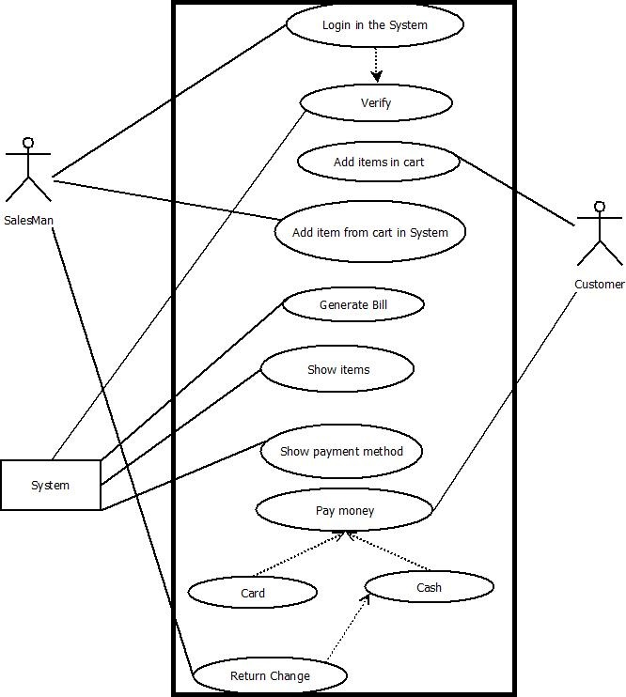

**Figure-1**

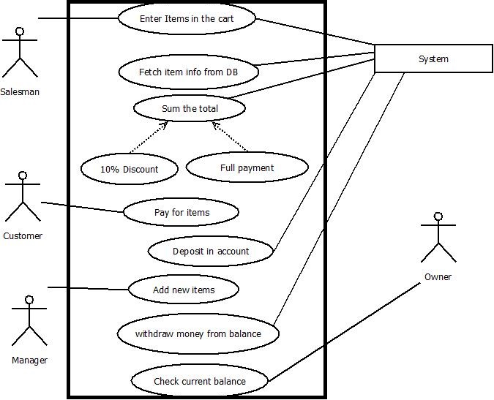

**Figure-2**

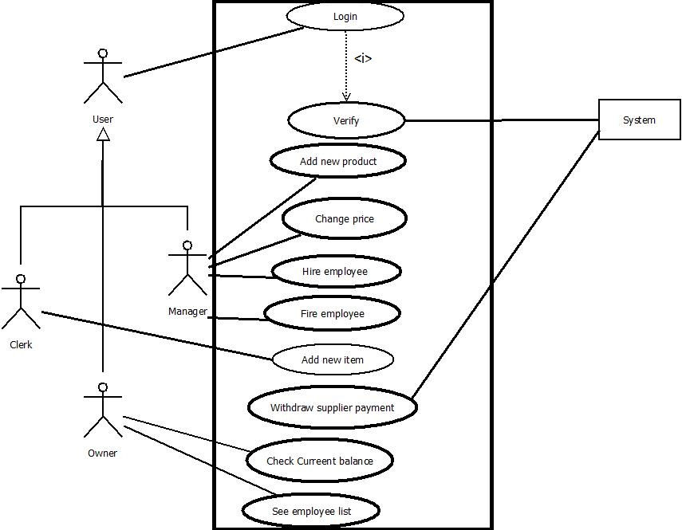

**Figure-3**

Class Diagram of the system:

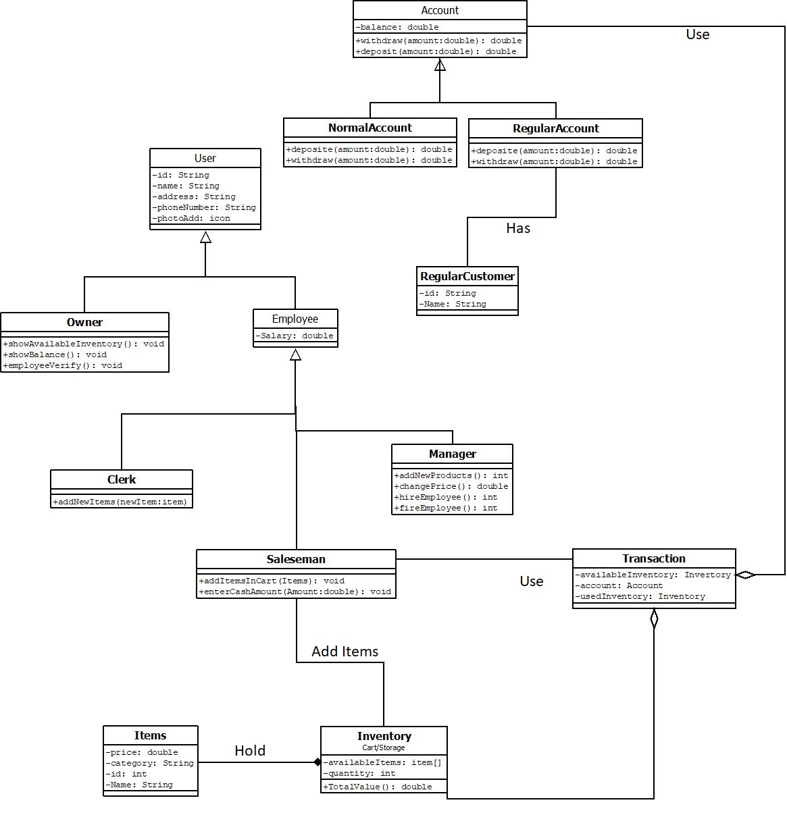

**Figure-4**

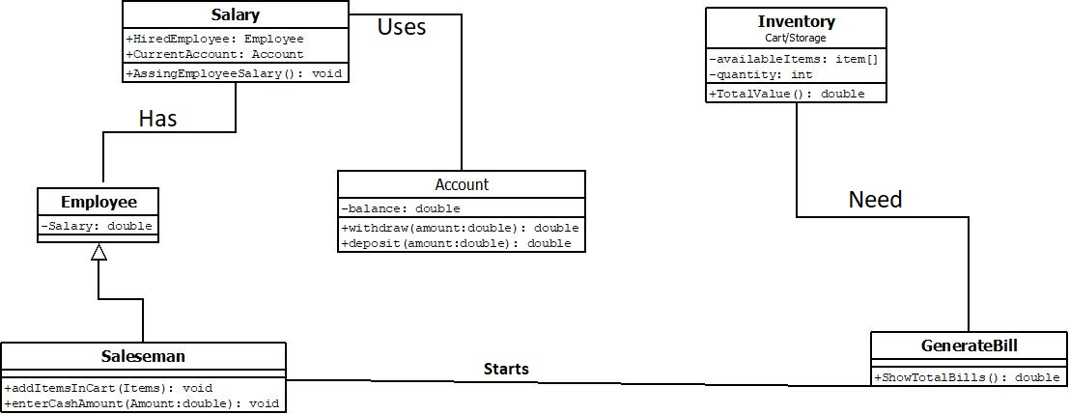

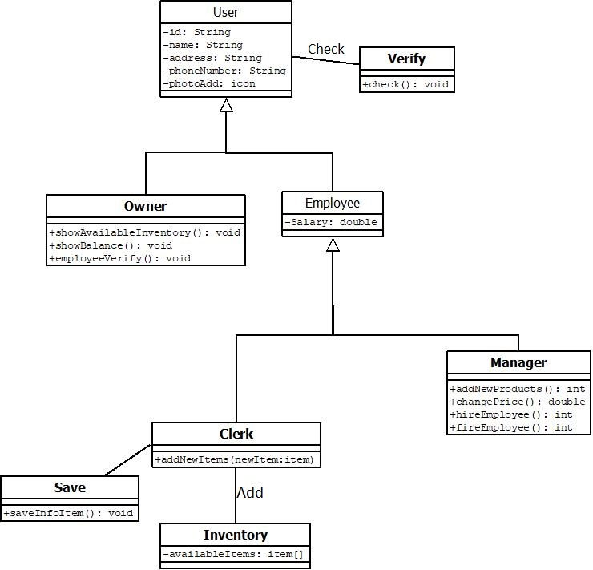

**Figure-5**

## System Interface

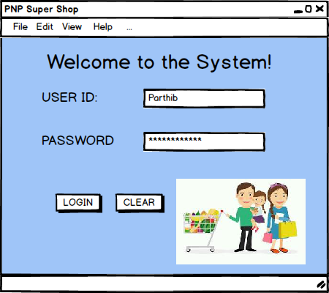

**Figure-6**

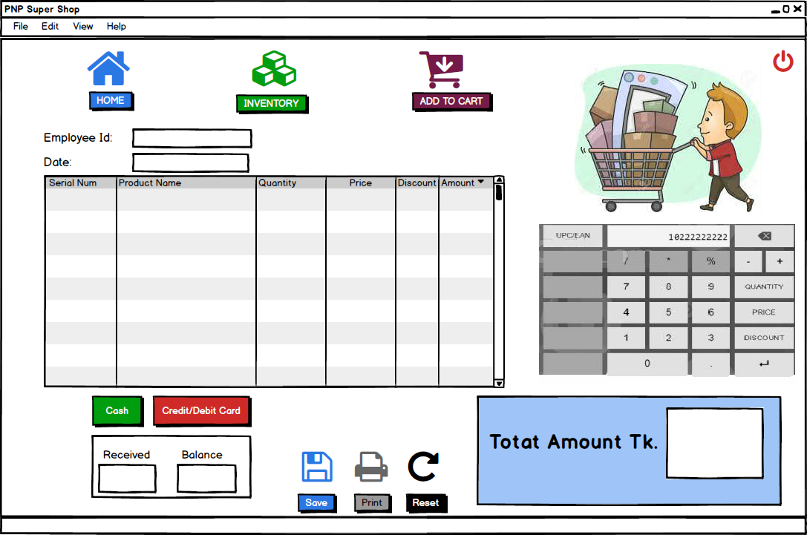

**Figure-7**

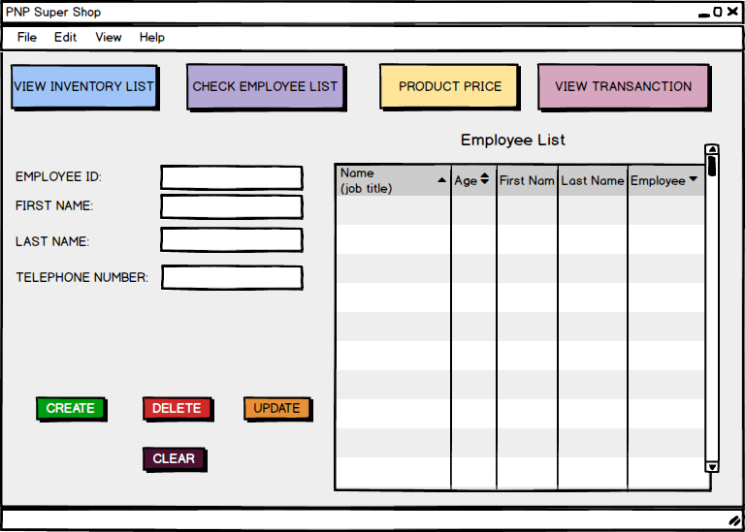

**Figure-8**

## Project Requirements

Various estimation is made for this system to increase the success rate. Since this is a low cost software, budget for the development process cannot be kept high. To get the maximum profit from current available budget, a organized schedule will help greatly. Also unexpected exception may occur while the development time box. Also, technology available for development team is limited. So with limited resource, proper utilization is a key factor. All of these factors has to be taken under consideration before creating the software. To get a clear idea on the prediction COCOMO model can be used. To fully implement our system, we are expecting to need 50K lines of code. Our system is fully desktop based. So it falls under Organic type of project. Therefore,

SLCO-Dependent Coefficient T=0.38

Project Complexity P =1.05

Effort=PM= Co-efficient*(SLOC/1000)^P

=2.4*(50)^1.05

=145.925

Development Time=DM=2.5*(PM)^T

=16.601

Required Number of People=ST=PM/DM

= 8.79

# Referesnce

1] *S*[*HOP MANAGEMENT SOFTWARE*](http://blog.devszone.com/shop-management-software/), Feb. 2013. Accessed on: Dec. 8, 2019. [Online]. Available: <http://blog.devszone.com/tag/shop-management-software/#.Xe8BlOgzbIV>

[2] Software Engineering: Stakeholder. (2019, March 12). Retrieved December 11, 2019, from <https://www.geeksforgeeks.org/software-engineering-stakeholder/>.

[3] What is a Functional Requirement? Specification, Types, EXAMPLES. (n.d.). Retrieved December 11, 2019, from <https://www.guru99.com/functional-requirement-specification-example.html>.

[4] Non-functional requirement. (2019, October 2). Retrieved December 11, 2019, from https://en.wikipedia.org/wiki/Non-functional_requirement.